Approved by Governors (date)………………………

Head Teacher…………………….............................
On behalf of Governors ……………………………

POLICY FOR PLAY

COMMITMENT
Our aim is to use this Play Policy to guide all decisions which affect children’s play. Our school is committed to providing careful and effective leadership that is needed to maintain quality play provision for all of our children.

RATIONALE
Our school believes that all children need opportunities to play that allows them to use their inspiration to explore the environment around them. We firmly believe that play provision should be supported by a welcoming and accessible environment, irrespective of gender, sexual orientation, economic or social circumstances and ethnic or cultural origins, allowing children to grow as individuals.
The OPAL Primary Programme rationale states that “…more active and creative playtimes can mean happier and healthier children, and having happier, healthier, more active children usually results in a more positive attitude to learning in school, with more effective classroom lessons, less staff time spent resolving unnecessary behavioural problems, fewer playtime accidents, happier staff and a healthier attitude to life.”

THE VALUE OF PLAY
Play is a range of intrinsically motivated activities completed for recreational pleasure and enjoyment. Play should be freely chosen; personally directed; and intrinsically motivated. Play may be completed individually or with other people or with the use of equipment.
At Castle View, we believe there are many benefits to play:
- Play enables children the freedom to express themselves.
- It is critical to children’s health and wellbeing, and for their emotional, social and intellectual development.
- Play provides children with the opportunities to share and explore their likes and dislikes. With this in mind, children will experience a wide range of emotions and learn to develop their ability to cope with these, including happiness and sadness, achievement and frustration, acceptance and rejection, confidence and fear.
- Play is imperative for social interaction, allowing children to communicate and negotiate.
- Play is a place where children learn their own limits and boundaries; it is a place where children feel safe and secure.

AIMS
Play at Castle View aims to:
- Provide a challenging and stimulating environment.
- Give opportunities for children to develop cooperative relationships with each other.
- Allow children to adopt a sensible approach to managing the risks they take.
- Build resilience and character within children.
- Provide opportunities for playing independently and cooperatively.
- Create a range of environments which support children’s exploration and play imaginatively.

RIGHTS
Castle View recognises that we have a legal obligation to implement the UN Convention on the Rights of the Child, which includes the right to play, recreation and leisure (Article 31) and the right of children to be listened to on matters important to them (Article 12). We acknowledge and accept that we have a duty as a school to take these rights seriously and listen to children’s views on their play.

BENEFIT AND RISK
Play is pivotal in enhancing children’s wellbeing and development. When planning play opportunities, “The goal is not to eliminate risk, but to weigh up the risks and benefits. No children will learn about risk if they are wrapped in cotton wool.” (Health and Safety Executive).

As a school, we are committed to providing opportunities for imaginative play while also recognising our duty of care in managing potential harm (see appendix 1). Our risk management efforts focus on protecting children from serious, long term and debilitating injury (so far as is reasonably practicable), whilst also enabling them to experience the benefits of play to the full. We recognise that, as well as being a potential source of frustration for children, overzealous safety measures may serve to restrict the very characteristics of play that make it such a beneficial process (Health and Safety Executive, 2012).
“Striking the right balance between protecting children from the most serious risks and allowing them to reap the benefits of play is not always easy. It is not about eliminating risk. Nor is it about complicated methods of calculating risks or benefits. In essence, play is a safe and beneficial activity. Sensible adult judgements are all that is generally required to derive the best benefits to children whilst ensuring that they are not exposed to unnecessary risk.”
(Health and Safety Executive, 2012).
This play policy represents an initial risk-benefit analysis that takes account the benefits of play and how we as a school will manage the associated risks on a day-to-day basis. This includes the type and level of supervision we will provide and the processes we have in place to maintain a ‘safe enough’ environment for playing. In doing so, this policy accounts for the majority of low-level risks that are likely to emerge whilst children are playing at play times; recognising that in general, children’s play is a low-risk activity. We will then produce further evidence of our decision-making processes, in the form of risk-benefit assessments, when the level of risk children could be exposed to is perceived to be above what is typically expected in terms of opportunities at play times.

SUPERVISION STYLES
During our school day, we have a supervision timetable where the staff to pupil ratio is greater than that recommended by the Department for Education. Castle View has recognised OPAL’s model for supervision: Direct, Remote and Ranging. Aside from children in EYFS, whose skills in the environment must be monitored more closely, our school does not believe that direct supervision is always beneficial. Our supervisors will, for the most part, follow the ranging or remote supervision model. However, all play supervisors have received adequate training in enabling them to make a dynamic risk assessment, and where they feel that play is presenting a high level of risk, a direct approach will be implemented. This will allow children to engage in imaginative play where certain levels of risk can emerge while also knowing that patrolling supervisors are readily available to seek onsite. Our supervisors will be allocated ‘zones’ of the schoolground for which they will patrol. See appendix 2 for an outline of our ground’s zones.

THE ADULT’S ROLE IN PLAY
All members of staff at Castle View have been trained in accordance with the Playwork Principles and these principles will be adhered to when appropriate interventions are needed. However, ultimately, our staff will strive for facilitating an environment which nurtures children’s self-directed play.
Playtime supervisors will create an environment which maximises opportunities for a range of play experiences and they are capable of enriching each child’s play experience physically and emotionally. Supervisors will also provide a breadth of new materials and equipment which may act as a stimulus for children’s exploration and learning.

EQUALITY AND DIVERSITY
Castle View will facilitate creative and imaginative play and we will ensure that all children, regardless of age, gender, race or disability, can flourish individually as well as form strong collaborative relationships in the school.

ENVIRONMENT
The rich play setting that we will create will allow all children to have access to inspiring environments which are free from unacceptable or unnecessary risks. We shall frequently and continually update and improve the quality of our school’s ground to enhance play.

Reviewed and updated: April 2025
Next review: April 2026

APPENDIX
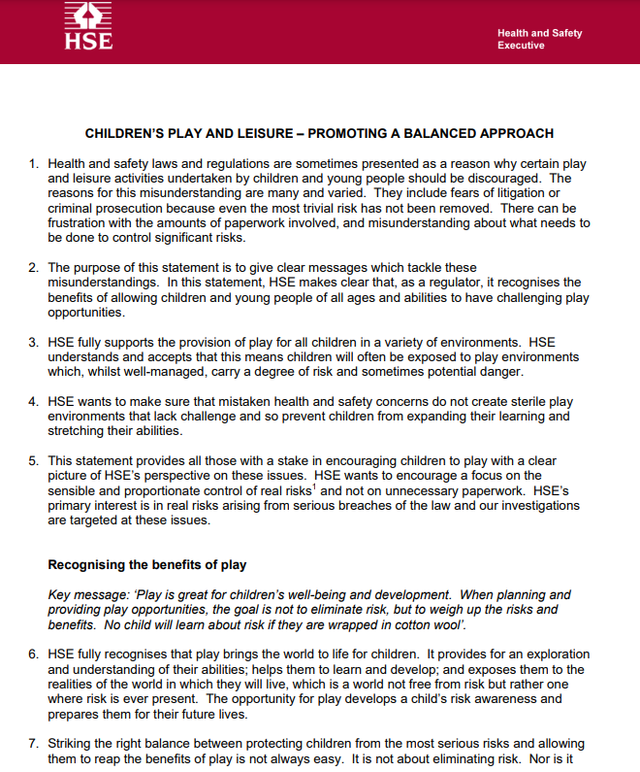
- HSE, Managing Risk.

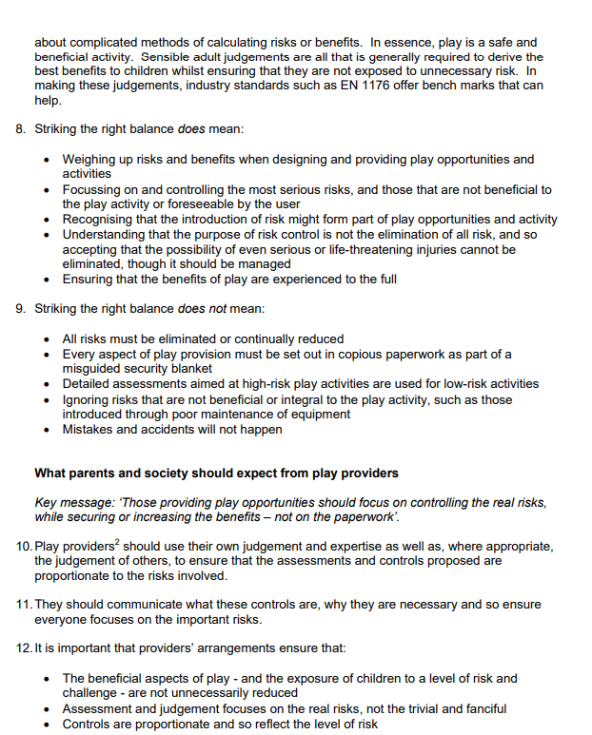

- School grounds.

